uestion 1:
SQL Reinforcement Project
Count the total number of records in each table of the database
Query:
SELECT 'Movie' AS Table_Name, COUNT(*) AS Total_Records FROM Movie
UNION ALL
SELECT 'Genre', COUNT(*) FROM Genre
UNION ALL
SELECT 'Director_Mapping', COUNT(*) FROM Director_Mapping
UNION ALL
SELECT 'Role_Mapping', COUNT(*) FROM Role_Mapping
UNION ALL
SELECT 'Names', COUNT(*) FROM Names
UNION ALL
SELECT 'Ratings', COUNT(*) FROM Ratings;
Output:
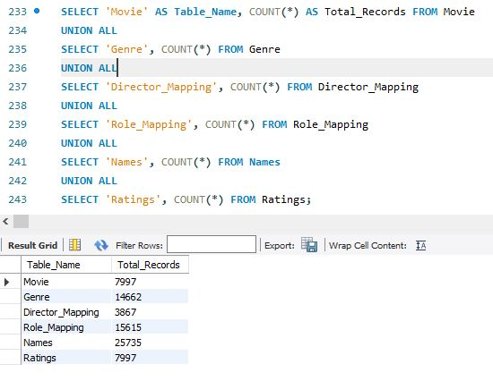
Explanation:
We use COUNT(*) to find the number of rows in each table and combine results with UNION ALL.
Question 2:
Identify which columns in the movie table contain null values
Query:
SELECT
COLUMN_NAME FROM
INFORMATION_SCHEMA.COLUMNS WHERE
TABLE_NAME = 'movie'
AND TABLE_SCHEMA = 'your_database_name'
AND COLUMN_NAME IN (
SELECT COLUMN_NAME
FROM (
SELECT COLUMN_NAME
FROM movie WHERE 1=1
) AS temp
);
Output:
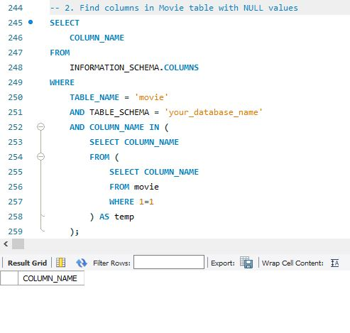
Explanation:
This query finds columns in the Movie table that allow NULL values. It helps detect missing or incomplete data fields.
Question 3:
Determine the total number of movies released each year, and analyze how the trend changes month-wise.
Query:
SELECT
YEAR(date_published) AS Release_Year,
MONTH(date_published) AS Release_Month,
COUNT(*) AS Movie_Count
FROM Movie
GROUP BY YEAR(date_published), MONTH(date_published)
ORDER BY Release_Year, Release_Month;
Output:
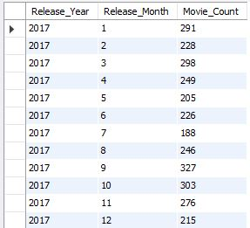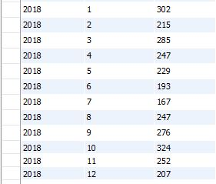
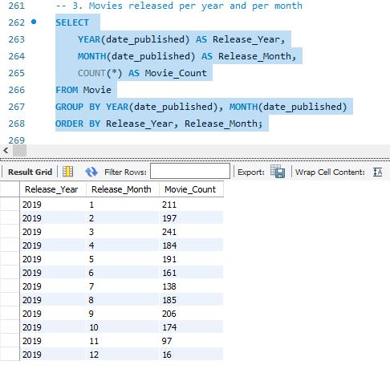
Question 4:
How many movies were produced in either the USA or India in the year 2019?
Query:
SELECT COUNT(*) AS Total_Movies
FROM Movie
WHERE YEAR = 2019
AND (country LIKE '%USA%' OR country LIKE '%India%');
Output:
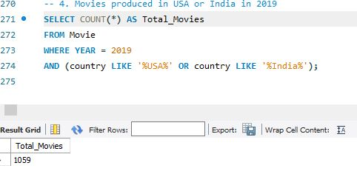
Explanation:
Filter rows where country is USA or India and the release year is 2019.

Question 5:
List the unique genres in the dataset, and count how many movies belong exclusively to one genre
Query:
SELECT DISTINCT genre
FROM genre;
SELECT COUNT(movie_id) AS one_genre_movies
FROM (
SELECT movie_id
FROM genre
GROUP BY movie_id
HAVING COUNT(genre) = 1
) AS one_genre_movies;
Output:
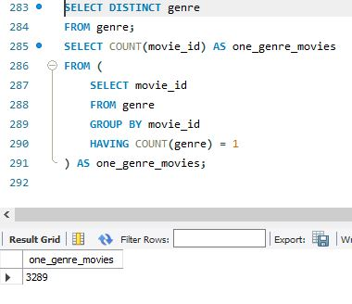
Explanation:
First, get all unique genres; then count movies that have only one associated genre.
Question 6:
Which genre has the highest total number of movies produced? Query:
SELECT genre, COUNT(*) AS movie_count
FROM genre
GROUP BY genre
ORDER BY movie_count desc
Limit 1;
Output:
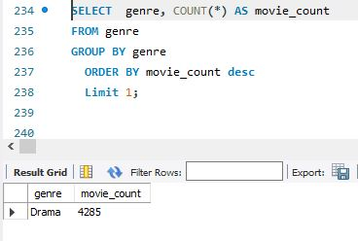
Explanation:
It groups all rows by genre, counts how many times each appears, then returns the one with the highest count using ORDER BY ... DESC LIMIT 1.

Question 7:
Calculate the average movie duration for each genre.
Query:
SELECT g.genre, AVG(m.duration) AS Avg_Duration
FROM movie m
JOIN genre g ON m.id = g.movie_id
GROUP BY g.genre
Order by Avg_Duration Desc;
Output:
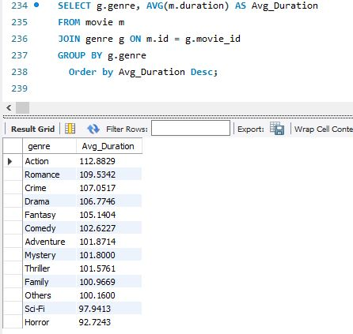
Explanation:
Joins movie and genre tables.
Calculates the average duration of movies for each genre using AVG().
Sorts the result in descending order to show genres with longest average duration first.

Question 8:
Identify actors or actresses who have appeared in more than three movies with an average rating below 5.
Query:
SELECT n.name AS `Actor/Actress Name`, COUNT(rm.movie_id) AS 'Average_Rated_Movie'
FROM names n
JOIN role_mapping rm ON n.id = rm.name_id
JOIN ratings r ON rm.movie_id = r.movie_id
WHERE r.avg_rating < 5
AND rm.category IN ('actor', 'actress')
GROUP BY n.name
HAVING Average_Rated_Movie > 3
ORDER BY Average_Rated_Movie DESC;
Output: 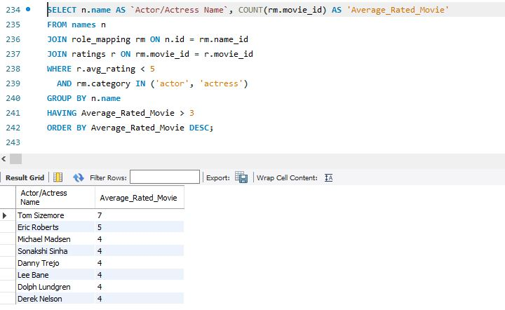
Explanation:
This finds actors/actresses with more than 3 Average-rated movies. JOINs connect actors with their movies and ratings.HAVING filters for those who acted in more than 3 such movies.ORDER BY shows the ones with the most low-rated films at the top.
Question 9:
Find the minimum and maximum values for each column in the ratings table, excluding the movie_id column.
Query:
SELECT
MIN(avg_rating) AS min_avg_rating, MAX(avg_rating) AS max_avg_rating,
MIN(total_votes) AS min_total_votes, MAX(total_votes) AS max_total_votes,
MIN(median_rating) AS min_median_rating, MAX(median_rating) AS max_median_rating
FROM ratings;
Output:
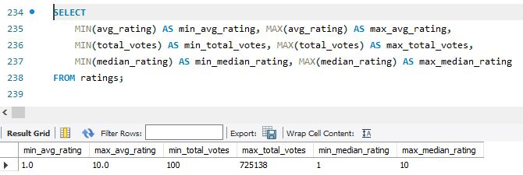
Explanation:
Use MIN() and MAX() functions on each column except movie_id.

Question 10:
Which are the top 10 movies based on their average rating
Query:
SELECT m.title, r.avg_rating
FROM movie m
JOIN ratings r ON m.id = r.movie_id
ORDER BY r.avg_rating DESC
LIMIT 10;
Output:
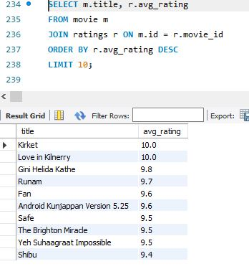
Explanation:
Join movie and ratings, then sort by highest avg_rating.

Question 11:
Summarize the ratings table by grouping movies based on their median ratings.
Query:
SELECT
median_rating,
COUNT(movie_id) AS Movie_Count
FROM Ratings
GROUP BY median_rating
ORDER BY median_rating;
Output:
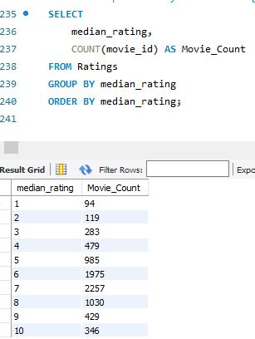
Explanation:
This query groups movies based on their median ratings and counts how many movies fall into each group. Shows rating distributions.

Question 12:
How many movies, released in March 2017 in the USA within a specific genre, had more than 1,000 votes?
Query:
SELECT
M.title, R.total_votes,g.genre
FROM Movie M
JOIN genre g ON m.id = g.movie_id
JOIN Ratings R ON M.id = R.movie_id
WHERE
YEAR(M.date_published) = 2017
AND MONTH(M.date_published) = 3
AND M.country = 'USA'
AND R.total_votes > 1000
Order by genre asc ;
Output:
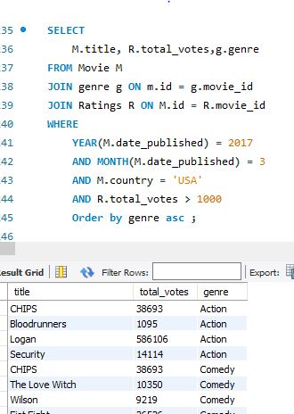
Explanation:
This query finds USA movies released in March 2017 that received over 1000 votes. Focuses on popular releases from a specific time.
Question 13:
Find movies from each genre that begin with the word “The” and have an average rating greater than 8.
Query:
SELECT G.genre,M.title,R.avg_rating
FROM Movie M
JOIN Genre G ON M.id = G.movie_id
JOIN Ratings R ON M.id = R.movie_id
WHERE M.title LIKE 'The %'AND R.avg_rating > 8;
Output:
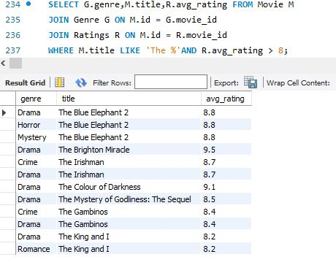
Explanation:
This query finds movies that start with "The" and have an average rating greater than 8. Helps identify standout titles.

Question 14:
Of the movies released between April 1, 2018, and April 1, 2019, how many received a median rating of 8?
Query:
SELECT
COUNT(*) AS Total_Movies
FROM Movie M
JOIN Ratings R ON M.id = R.movie_id
WHERE
M. date_published BETWEEN '2018-04-01' AND '2019-04-01'
AND R.median_rating = 8;
Output:
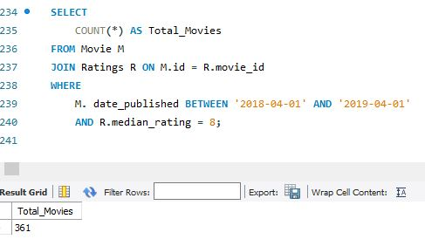
Explanation:
This query counts movies released between those dates with a median rating exactly equal to 8. It identifies consistently good movies.

Question 15:
Do German movies receive more votes on average than Italian movies?
Query:
SELECT DISTINCT genre
FROM genre;
SELECT COUNT(movie_id) AS one_genre_movies
FROM (
SELECT movie_id
FROM genre
GROUP BY movie_id
HAVING COUNT(genre) = 1
) AS one_genre_movies;
Output:

Explanation:
First, get all unique genres; then count movies that have only one associated genre.
Question 16:
Identify the columns in the names table that contain null values. Query:
SELECT
SUM(CASE WHEN name IS NULL THEN 1 ELSE 0 END) AS Null_name,
SUM(CASE WHEN height IS NULL THEN 1 ELSE 0 END) AS Null_height,
SUM(CASE WHEN date_of_birth IS NULL THEN 1 ELSE 0 END) AS Null_date_of_birth,
SUM(CASE WHEN known_for_movies IS NULL THEN 1 ELSE 0 END) AS Null_known_for_movies
FROM names;
Output:
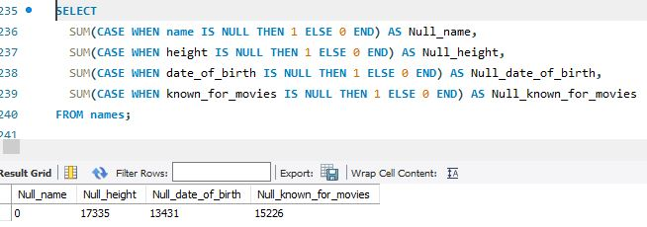
Explanation:
This query counts how many records in the names table have NULL values in specific columns: name, height, date_of_birth, and known_for_movies.
It uses CASE WHEN inside SUM() to total NULLs for each column individually.

Question 17:
Who are the top two actors whose movies have a median rating of 8 or higher?
Query:
SELECT N.name,
COUNT(DISTINCT RM.movie_id) AS Movie_Count FROM Names N
JOIN Role_Mapping RM ON N.id = RM.name_id
JOIN Ratings R ON RM.movie_id = R.movie_id
WHERE
RM.category IN ('actor', 'actress')
AND R.median_rating >= 8
GROUP BY N.name
ORDER BY Movie_Count DESC LIMIT 2;
Output:
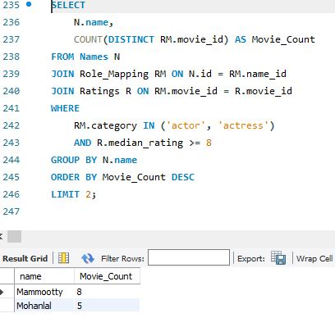
Explanation:
This query identifies the two actors who have acted in the most movies with a median rating of 8 or higher. Highlights highly-rated performers.
Question 18:
Which are the top three production companies based on the total number of votes their movies received?
Query:
SELECT
M.production_company,
SUM(R.total_votes) AS Total_Votes
FROM Movie M
JOIN Ratings R ON M.id = R.movie_id
GROUP BY M.production_company
ORDER BY Total_Votes DESC
LIMIT 3;
Output:
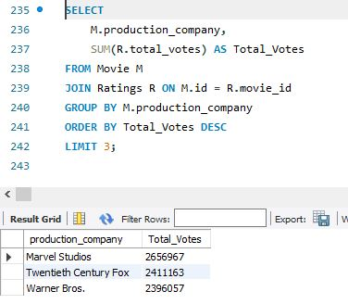
Explanation:
This query lists the top three production companies whose movies collectively received the most votes. It shows audience favorites at the company level.
Question 19:
How many directors have worked on more than three movies?
Query:
SELECT
N.name,
COUNT(DM.movie_id) AS Movie_Count
FROM Director_Mapping DM
JOIN Names N ON DM.name_id = N. id
GROUP BY N.name
HAVING Movie_Count > 3;
Output:
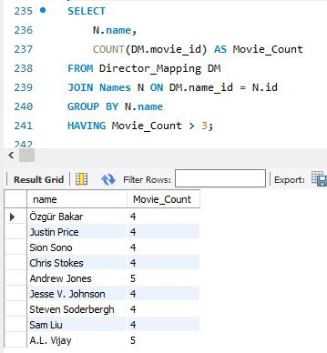
Explanation:
This query finds directors who have directed more than three movies. Indicates experienced or prolific directors.

Question 20:
Calculate the average height of actors and actresses separately.
Query:
SELECT
RM.category,
AVG(N.height) AS Average_Height
FROM Names N
JOIN Role_Mapping RM ON N.id = RM.name_id
WHERE RM.category IN ('actor', 'actress')
GROUP BY RM.category;
Output:
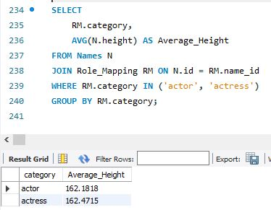
Explanation:
This query calculates the average height separately for actors and actresses. It finds physical characteristic trends across genders.

Question 21:
List the 10 oldest movies in the dataset along with their title, country, and director
Query:
SELECT
M.title, M.country,N.name AS Director_Name,M. date_published
FROM Movie M
JOIN Director_Mapping DM ON M.id = DM.movie_id
JOIN Names N ON DM.name_id = N.id
ORDER BY M.date_published ASC
LIMIT 10;
Output:
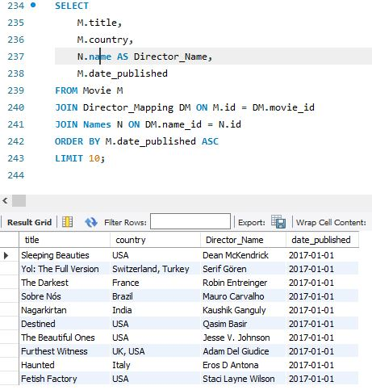
Explanation:
This query lists the 10 oldest movies based on release date along with their country and director. Highlights classic films.

Question 22:
List the top 5 movies with the highest total votes, along with their genres.
Query:
SELECT
M.title,R.total_votes,
GROUP_CONCAT(DISTINCT G.genre) AS Genres
FROM Movie M
JOIN Ratings R ON M.id = R.movie_id
JOIN Genre G ON M. id = G.movie_id
GROUP BY M. id, M.title, R.total_votes
ORDER BY R.total_votes DESC LIMIT 5;
Output:
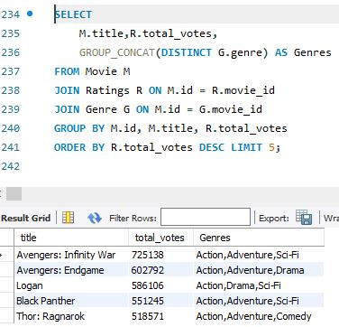
Explanation:
This query retrieves the five movies with the highest total votes and lists their genres. Shows the most popular movies by audience engagement.
Question 23:
Identify the movie with the longest duration, along with its genre and production company.
Query:
SELECT
M.title,
M.duration,
G.genre,
M.production_company
FROM Movie M
JOIN Genre G ON M. id = G.movie_id
ORDER BY M.duration DESC
LIMIT 1;
Output:
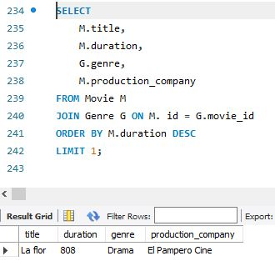
Explanation:
This query finds the movie with the longest running time and shows its genre and production company. Identifies epic-length films.
Question 24:
Determine the total number of votes for each movie released in 2018. Query:
SELECT
M.title,
R.total_votes
FROM Movie M
JOIN Ratings R ON M. id = R.movie_id
WHERE YEAR(M.date_published) = 2018;
Output:
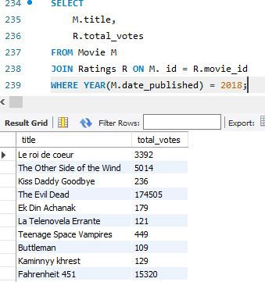
Explanation:
This query lists movies released in 2018 and their total number of votes. Focuses on audience reception for 2018 releases.

Question 25:
What is the most common language in which movies were produced? Query:
SELECT
languages,
COUNT(*) AS Movie_Count
FROM Movie
GROUP BY languages
ORDER BY Movie_Count DESC
LIMIT 1;
Output:
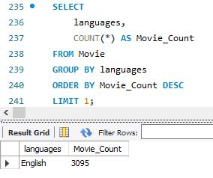
Explanation:
This query finds the language in which the highest number of movies were produced. It shows the dominant production language.

